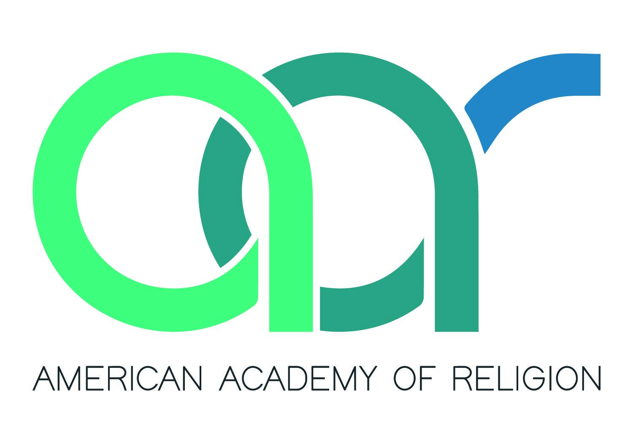***Call for Proposals***

**2025 Rocky Mountain-Great Plains (RMGP) Regional Meeting**

**Hosted by the RMGP Region of the AAR & the Religion and Bible Society**

On behalf of the University of Denver RMGP Regional Conference Committee, we invite proposals for panels and papers to be presented at the 2025 Rocky Mountain Great Plains Regional Meeting, which will be held at the University of Denver in Denver, CO, Friday-Saturday March 28-29, 2025. Thedeadline for submissions is **Friday**, **November 29, 2024, 11:59pm Mountain Time.**  
  
We welcome proposals dealing with any aspect of the fields of religious studies and biblical studies. We seek proposals on all topics pertaining to religious traditions, beliefs, texts, or practices; historical periods; and biblical texts and their traditions. We also welcome proposals from scholars in a range of fields and disciplines; religious studies is an inherently inter- and multidisciplinary field.

We welcome proposals for panels of multiple papers and accept proposals for single papers or other types of sessions, such as roundtables or book panels involving structured discussions of pre-circulated questions.

We strongly encourage submissions of complete panels and especially encourage panels that include presenters from multiple institutions and with a range of career stages and job positionalities. Panel submissions must include a suggested chair and may include a respondent.

**Proposal Requirements:**  
All proposals must follow the instructions listed below. Proposals must be submitted via Google Forms here: <https://forms.gle/KjdxbhunAFWefpkC9>

Please make sure to include the following information in each proposal. Respondents and suggested chairs for panels do not need to fill out a title or abstract but should be noted as “Respondent” or “Proposed Chair” in the presenters’ sections.  
  
Panel Proposals  
1) tentative title  
2) panel organizer name  
3) panel organizer institutional affiliation  
4) panel organizer preferred email address  
5) panel abstract (300 word maximum) that discusses the subject and significance of the session  
6) presenters’ names  
7) presenters’ institutional affiliations  
8) presenters’ email addresses  
9) presenters’ individual abstracts (300 word maximum each), each discussing the subject and methodology of the paper, as well as the significance of the subject within the broader field of interest  
10) technology needed  
  
Individual Paper Proposals  
1) tentative title  
2) presenter name/s  
3) presenter/s institutional affiliation/s  
4) presenter/s email address/es  
5) abstract (300 words maximum) that discusses the subject and methodology of the paper, as well as the significance of the subject within the broader field of interest  
6) technology needed  
  
Roundtables, Book Panels, and Other Sessions  
1) tentative title  
2) session organizer name  
3) session organizer institutional affiliation  
4) session organizer email address  
5) session abstract (300 words maximum) that describes the format, subject, and significance of the session  
6) technology needed

**Undergraduate Student Panel:**  
To foster undergraduate involvement in the 2025 Regional Meeting, we continue our tradition of organizing an undergraduate student panel. Please encourage undergraduate students you know to consider submitting a paper.

Undergraduates who would like to submit an abstract for this session must follow the Individual Paper Proposals guidelines outlined above and ***note in the abstract section*** that they are submitting for the undergraduate session. In the abstract section, please also include the name and email address of a faculty member from the student’s institution who is familiar with the student’s work.

**Non-Discrimination Policy:**

Please note that in order to ensure a welcoming and inclusive space for everyone, all conference presenters and attendees agree to follow the [Rocky Mountain – Great Plains Region Non-Discrimination Policies and Procedures](https://docs.google.com/document/d/1F0aqtGC5KGv_95IcKBvM9QYZg8T5uq95/edit?usp=sharing&ouid=117595390505089491112&rtpof=true&sd=true). Here is the link: <https://rb.gy/ebrz3e>

**Program Committee:**  
The Program Committee will review all proposals using a rubric and will meet via Zoom in December to discuss final program selections.  
  
The 2025 Regional Meeting chairs, Dr. Dheepa Sundaram ([dheepa.sundaram@du.edu](mailto:dheepa.sundaram@du.edu)) and Dr. Andrea Stanton ([andrea.stanton@du.edu](mailto:andrea.stanton@du.edu)), invite members of the Rocky Mountain Great Plains Region to serve on the Program Committee. We hope that at least one faculty member from each of the participating institutions in the RMGP region will serve.  
  
Please notify the chairs by **Friday, November 15** if you are willing to serve on the Program Committee.

**Conference Costs:**

All conference attendees will pay a registration fee, as follows: $20 for students and adjunct faculty members or independent scholars; $30 for non tenure-track faculty; and $75 for tenure-track faculty. Conference registration includes two lunches and a light reception.

The organizers have secured rooms at the Marriott Courtyard near campus, which has free parking for guests, at a rate of $113 per night, plus taxes.

We look forward to receiving your proposal! Please reach out with any questions regarding programming, costs, or other concerns.

Thank you!

Dheepa Sundaram and Andrea Stanton

•••

The 2025 RMGP Regional Meeting is sponsored by the American Academy of Religion, the Department of Religious Studies, the College of Arts, Humanities, and Social Sciences, and the Office of Research and Sponsored Programs at the University of Denver.